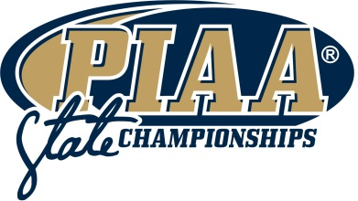
KIND Snack Foods PIAA Sportsmanship Award
2017 Nomination Form Instructions

Eligibility:

- With limited restrictions, all Pennsylvania Interscholastic Athletic Association member school male and female student-athletes are eligible for the 2017 KIND Snack Foods Sportsmanship Award. An award will be given to one deserving male and one deserving female student-athlete.

Format:

- All nominations must be completed on the official nomination form.
- Typed entries are strongly encouraged.
- Attach additional sheets as needed.
- Please limit nomination forms to no more than TWO pages, double-spaced.

What to Include:

- The nomination shall be for an act, or several acts of sportsmanship that are student-initiated, selfless, reflected concern for an opponent, and exemplify the highest ideals of interscholastic competition.
- Nominations should be detailed and specific, providing examples of merit wherever possible.

Of Note:

- The PIAA Sportsmanship Committee will hold all nominations in confidence.
- Nominations may be resubmitted in subsequent years, but nominations will not be carried over automatically.

Deadline:

- Completed nominations are due by 5:00 p.m. on Friday, March 3, 2017.
- There will be no exceptionS to the nomination deadline.

Presentation:

- Winner to be presented the KIND Snack Foods Sportsmanship Awards in person during the PIAA Basketball Championship Finals held at the Giant Center in Hershey, PA on Saturday, March 25th, 2017.

SNACK FOODS SPORTSMANSHIP AWARD

Nomination Form

Nominee: | School District:
Nominated By:  Print Name(s)  Please Check one:  PIAA Student Athlete  PIAA Athletic Director | Signature(s) **REQUIRED**
PIAA Coach
10/9/01 8:42 AM
PIAA Member School Administrator

Please indicate below how the nominee demonstrated an act, or several acts of sportsmanship that were student-initiated, selfless, reflected concern for an opponent, and exemplified the highest ideals of interscholastic competition. Please attach additional sheets as needed.

Thank you for participating in the KIND Snack Foods Sportsmanship Award nomination! Please make sure the form is complete and returned no later than 5:00 p.m. Friday, March 3, 2017 to:
By mail:
Mark Byers
PIAA Chief Operating Officer
550 Gettysburg Road
Mechanicsburg, PA 17055-0708
By email: mbyers@piaa.org
By fax: (717) 697-7721

