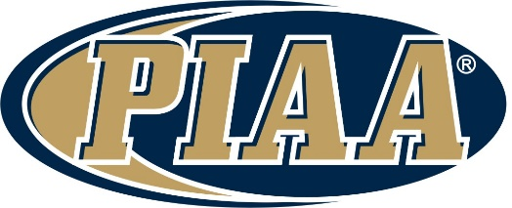

PIAA is currently seeking applicants to fulfill the duties and responsibilities of the statewide rules’ interpreter in the sport of girls’ lacrosse. This position acts as an extension of the PIAA Office regarding the sport of girls’ lacrosse, the administration of contests within the rules of girls’ lacrosse, and to act as an expert within Pennsylvania regarding this sport.
This position acts in concert with the PIAA Director of Officiating Services and Sport, and will perform the duties listed below:
- Provides rule interpretations and responds to questions concerning contest administration and officiating mechanics from chapter rules interpreters, coaches, and other school officials. When indicated, responds to the questions and inquiries, in writing, and forwards a copy of this written response to the PIAA Director of Officiating Services and Sport.

- Periodically, prior to and/or during the sport’s season, prepares and forwards memorandums, chapter meeting guides and bulletins to the PIAA Director of Officiating Services and Sport for their review and distribution to all PIAA district and chapter rules interpreters.

- Establishes and maintains communications, continuously, with PIAA chapter rules interpreters on a statewide basis.

- Keeps the PIAA Director of Officiating Services and Sport continuously in communication concerning any problems related to rules interpretations and applications, contest administration, and officiating mechanics that are occurring throughout the Commonwealth.

- Attends the annual NFHS Rules Interpreters Meeting for girls’ lacrosse, if necessary.

- Conducts the annual PIAA Rules Interpretation Meetings for chapter interpreters and attends both rules and chapter meetings on a regular basis.

- Develops and implements procedures to ensure that rules interpretations in girls lacrosse are uniform and consistent throughout the Commonwealth. This may involve the use of video and other forms of advancing technology.

- At the conclusion of the sport’s season, submit correspondence, in writing, to the PIAA Director of Officiating Services and Sport overseeing the Officials Program concerning how rules interpretations meetings and rules interpretations, in general, can be made more effective throughout the Commonwealth.

- Attends and promotes the Annual Officials’ Convention and assists in suggesting session topics, presenting, and acquiring speakers for those sessions.

- Attends the state championships and acts as the final authority regarding rules interpretations during the championship contest(s),
Applicants should have a minimum of five (5) years’ experience officiating girls lacrosse and an unquestioned knowledge of the rules and its officiating mechanics.
Applicants must possess excellent communication skills due to the wide range of persons with which this position interacts.
The following attributes are preferred for this position, but not required:
- Playing experience in interscholastic girls’ lacrosse and advanced levels
- Interscholastic girls’ lacrosse officiating at an advanced level, including playoffs
- Holding a post-secondary degree
- Experience as a chapter rules interpreter
- Well versed in technology and its continuing advancements as it may relate to the training of officials
This position receives a stipend and reimbursement for any out of pocket expenses incurred related to the performance of the duties of this positon.
Interested officials, currently in good standing in the sport of girls’ lacrosse should submit correspondence to PIAA office by the close of business, Friday April 24, 2026 expressing their interest in serving in this most important position.
This correspondence should include their training and experience in the sport of girls’ lacrosse along with any other information that would be pertinent to the position, and which would also provide PIAA any valuable information prior to making the final selection. Three references are requested and may be contacted to provide background information, if necessary.
Interviews will be conducted of selected officials in the month of May 2026.
Submit correspondence and direct any questions to Alex J. Mykut, PIAA Director of Officiating Services and Sport, at amykut@piaa.org or (717) 697-0374 ext. *102

